PROJECT TITLE : AI WEATHER-WISEAPI

TEAM ID : 6ab7eb21b8bf817b7f724a7d
TEAM LEADER:

AKASH K | akashk22037@gmail.com
TEAM MEMBER:

NAME | EMAIL
TANVINTHARAN M | tanvintanvin21@gmail.com
KAMARESH A | kamaresharumugam@gmail.com
VISHAL A | jayaanand0705@gmail.com

1

WEATHERWISE
AI-Powered Weather API Project

Node.js • Express • MongoDB
OpenWeather API • Google AI Studio / Gemini AI
API testing with Thunder Client

Introduction
2

  - WeatherWise is a web-based weather application with a RESTful backend.
  - The project combines weather data with AI-generated summaries and recommendations.
  - Users can register, log in and access protected API features.
  - The backend is built with Node.js and Express, with MongoDB used
for data storage.
  - Weather and AI services are connected through API integrations.

Objectives
3

  - Provide weather information for a selected city.
  - Create secure user registration and login using authentication.
  - Allow users to manage favorite locations.
  - Generate an AI weather summary from weather conditions.
  - Generate AI-based weather recommendations.
  - Demonstrate practical REST API development and API testing.

Technologies & Tools Used
4

  - Node.js – server-side JavaScript runtime.
  - Express.js – REST API and route handling.
  - MongoDB with Mongoose – database and data modelling.
  - Google Generative AI / Gemini – AI weather insights.
  - OpenWeather – weather data source.
  - JWT and bcryptjs – authentication and password security.
  - Thunder Client – API request and response testing.
  - VS Code – development environment.

System Architecture & Workflow

Express REST API

MongoDB

OpenWeather
5

User / Frontend

Gemini AI

1. User sends a request → 2. Express processes the request → 3. Database/service is accessed → 4. JSON response is returned.
Weather data is obtained from the weather service, while AI endpoints use weather values to generate human-readable insights

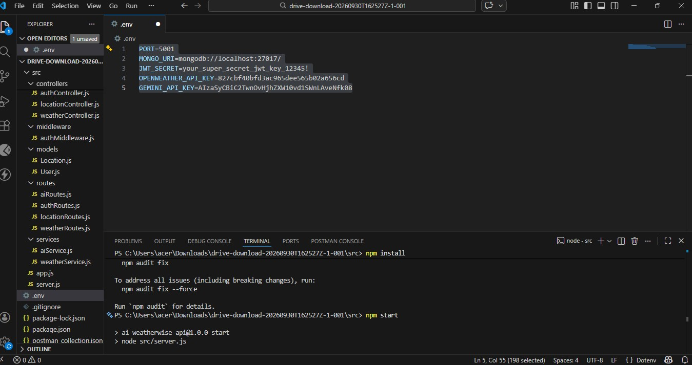
- RUN AND Connecting server to mongodb

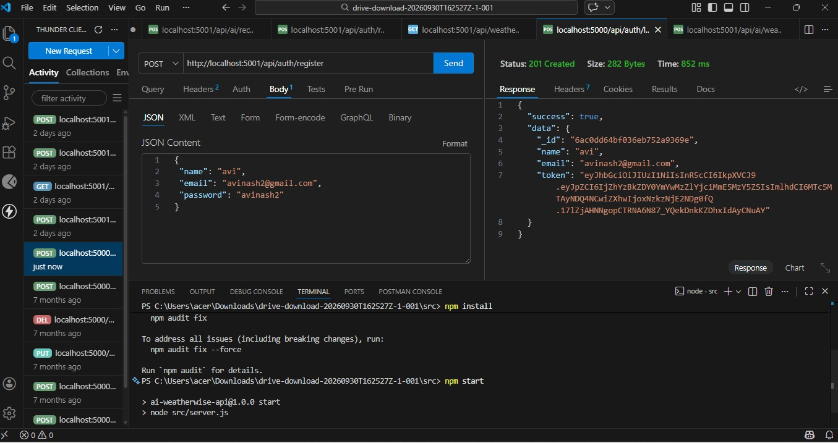
- User Authentication – REGISTER API

- 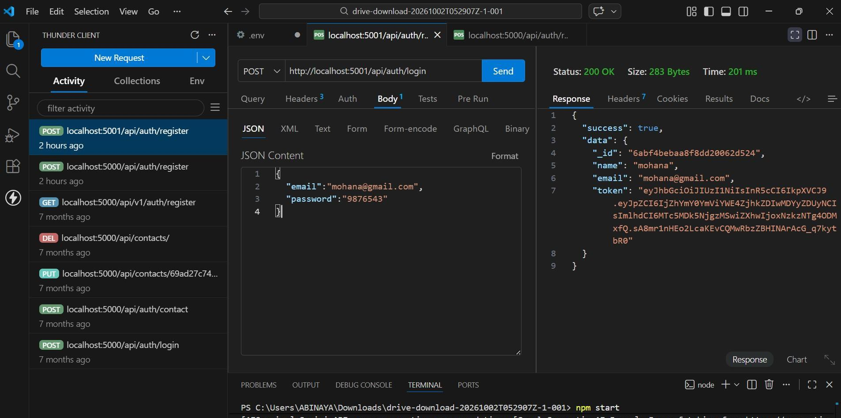User Authentication – Login API
Thunder Client test result

6

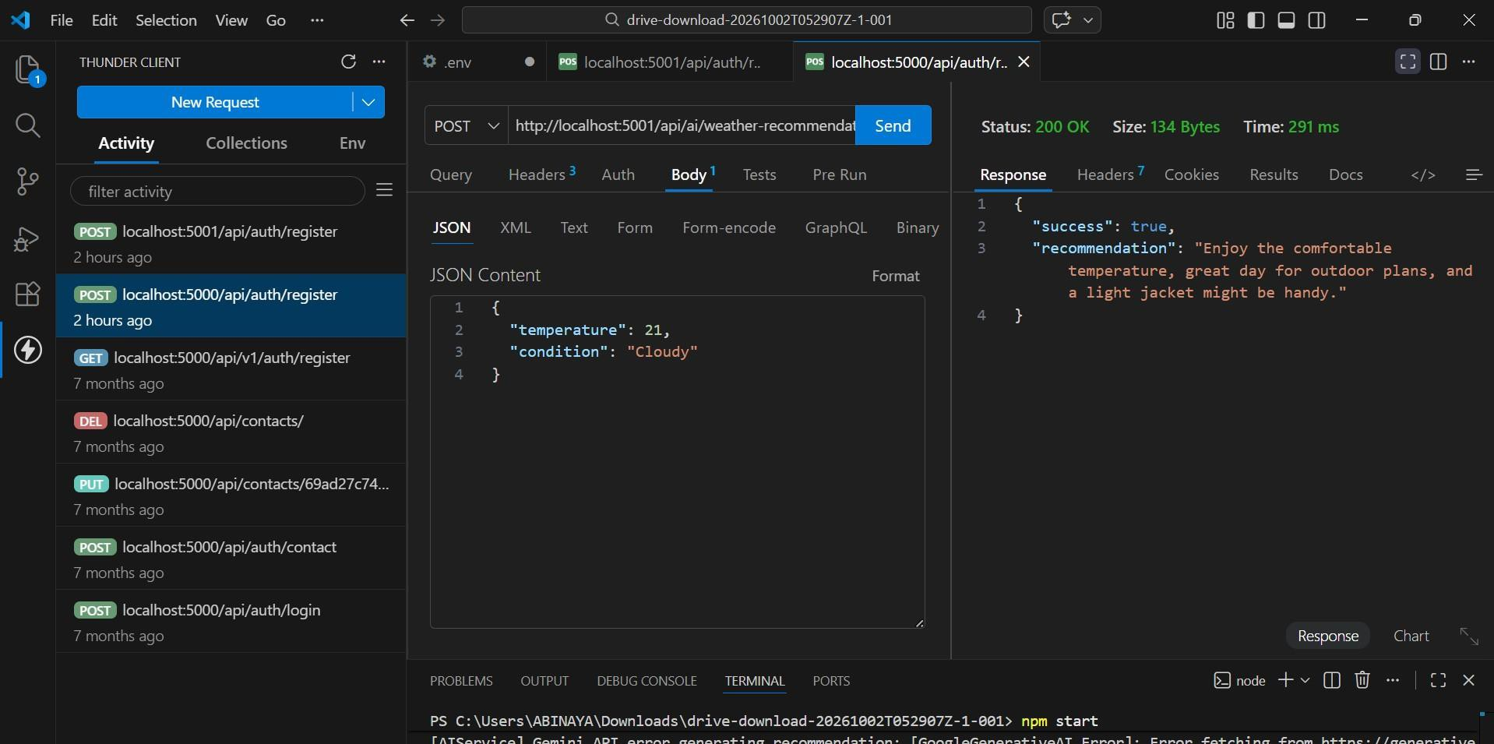AI Weather Recommendation
Thunder Client API request and response

7

Main API Modules
8

  - Authentication: Register User, Login User and Get User Profile.
  - Locations: Add, View, Update and Delete favorite locations.
  - Weather: Get current weather for a city.
  - AI Insights: Generate AI weather summary and AI weather
recommendation.
  - Protected endpoints use bearer-token authentication where required.

API Testing & Results
9

  - Thunder Client is used to send HTTP requests and inspect JSON
responses.
  - The Login API screenshot shows a successful 200 OK response with
user data and an authentication token.
  - The AI recommendation test shows a successful 200 OK response
containing a generated recommendation.
  - The screenshots represent the current project testing stage.
  - The terminal also shows a Gemini API-key error message in the captured run, indicating that the AI configuration needs a valid key for reliable AI generation.

Features & Future Enhancements
10

  - Current features: authentication, favorite locations, current weather,
AI summary and AI recommendation.
  - Future enhancement: add multi-day forecast and hourly forecast views.
  - Future enhancement: add automatic location detection and weather
maps.
  - Future enhancement: improve AI prompts and provide more
personalized recommendations.
  - Future enhancement: add a polished responsive frontend dashboard.

Conclusion
11

  - WeatherWise demonstrates practical REST API development with weather and AI integrations.
  - The project combines authentication, database operations, external
weather data and Gemini-based insights.
  - API testing confirms successful authentication and AI
recommendation responses in the captured tests.
  - The project can be extended into a complete AI-assisted weather dashboard.

11

THANK YOU

